UNITED STATES DISTRICT COURT
FOR THE NORTHERN DISTRICT OF TEXAS
FORT WORTH DIVISION

FIRST CALL INTERNATIONAL, INC.

Plaintiff,

v. No. 4:23-CV-00199-P

S&B GLOBAL AMERICA, INC.,
S&B GLOBAL, INC.,
SUNG JAE HWANG, AND
BO YOON CHI

Defendants.

APPENDIX TO PLAINTIFF’S RESPONSE TO DEFENDANT’S MOTION TO DISMISS AND REQUEST FOR JURISDICTIONAL DISCOVERY
OSCAR GONZALEZ
Texas Bar No. 08129240
oscarg@internationaltrade.law
(469) 774-4793
RUTH R. RODRIGUEZ
Texas Bar No. 17148550
ruthr@internationaltrade.law
(469) 767-0367
GONZALEZ ROLON VALDESPINO &
RODRIGUEZ, LLC
2911 Turtle Creek Boulevard, Suite 300
Dallas, Texas 75219
Telephone: 214-720-7720
ATTORNEYS FOR PLAINTIFF,
FIRST CALL INTERNATIONAL INC.

APPENDIX TABLE OF CONTENTS

Declaration of Joseph Pavlov ………………………...………..……..… Page 3
.
Declaration of Law Professor Dae Un Hong …………………...…....… Page 7
.
Henderson v. Republic of Tex. Biker Rally, Inc.,
No. 16-50171 (5th Cir. Dec. 6, 2016) …………….………,,…….…..…. Page 9

Bowles v. Ranger Land Sys., Inc.,
527 F. App'x 319 (5th Cir. 2013) …………………………………….……………………….……. Page 13

Anderson-Tully Lumber Co. v. Int'l Forest Products, S.R.L.,
Civil Action No. 5:05-cv-68(DCB)(JCS) (Sep. 5, 2006).….………..…. Page 16

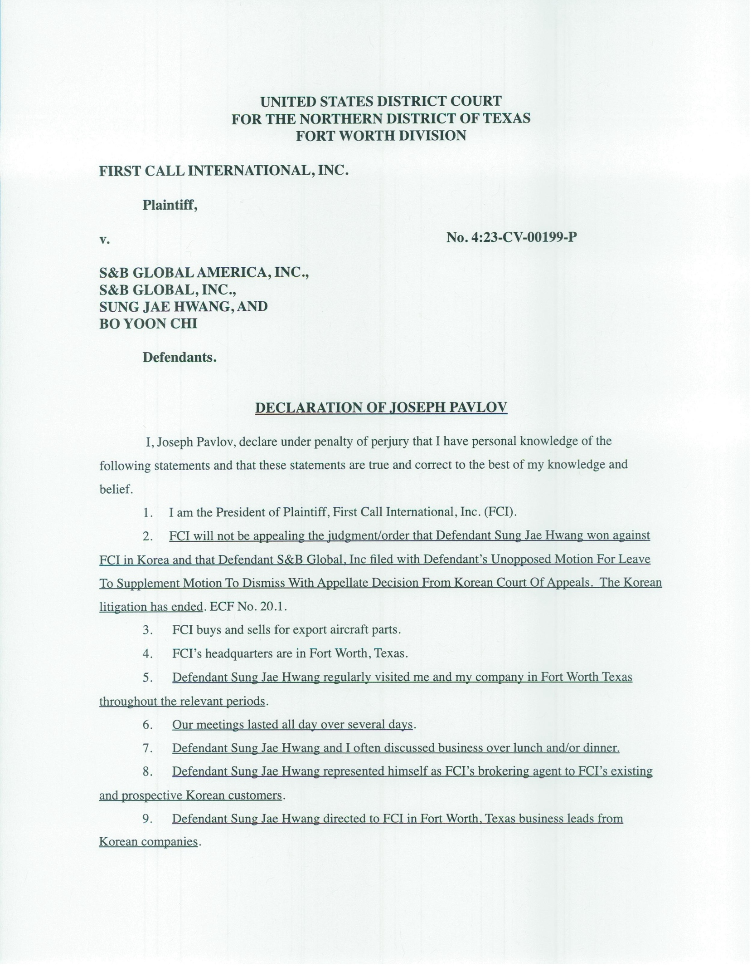
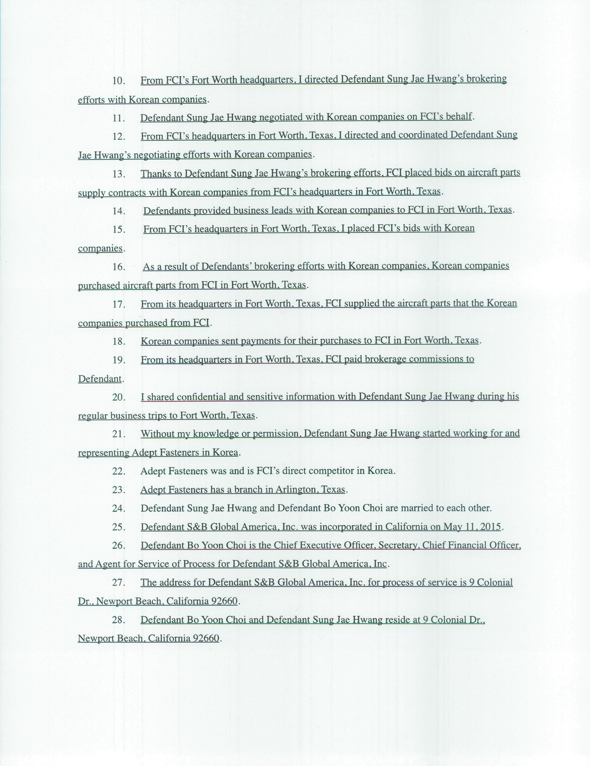
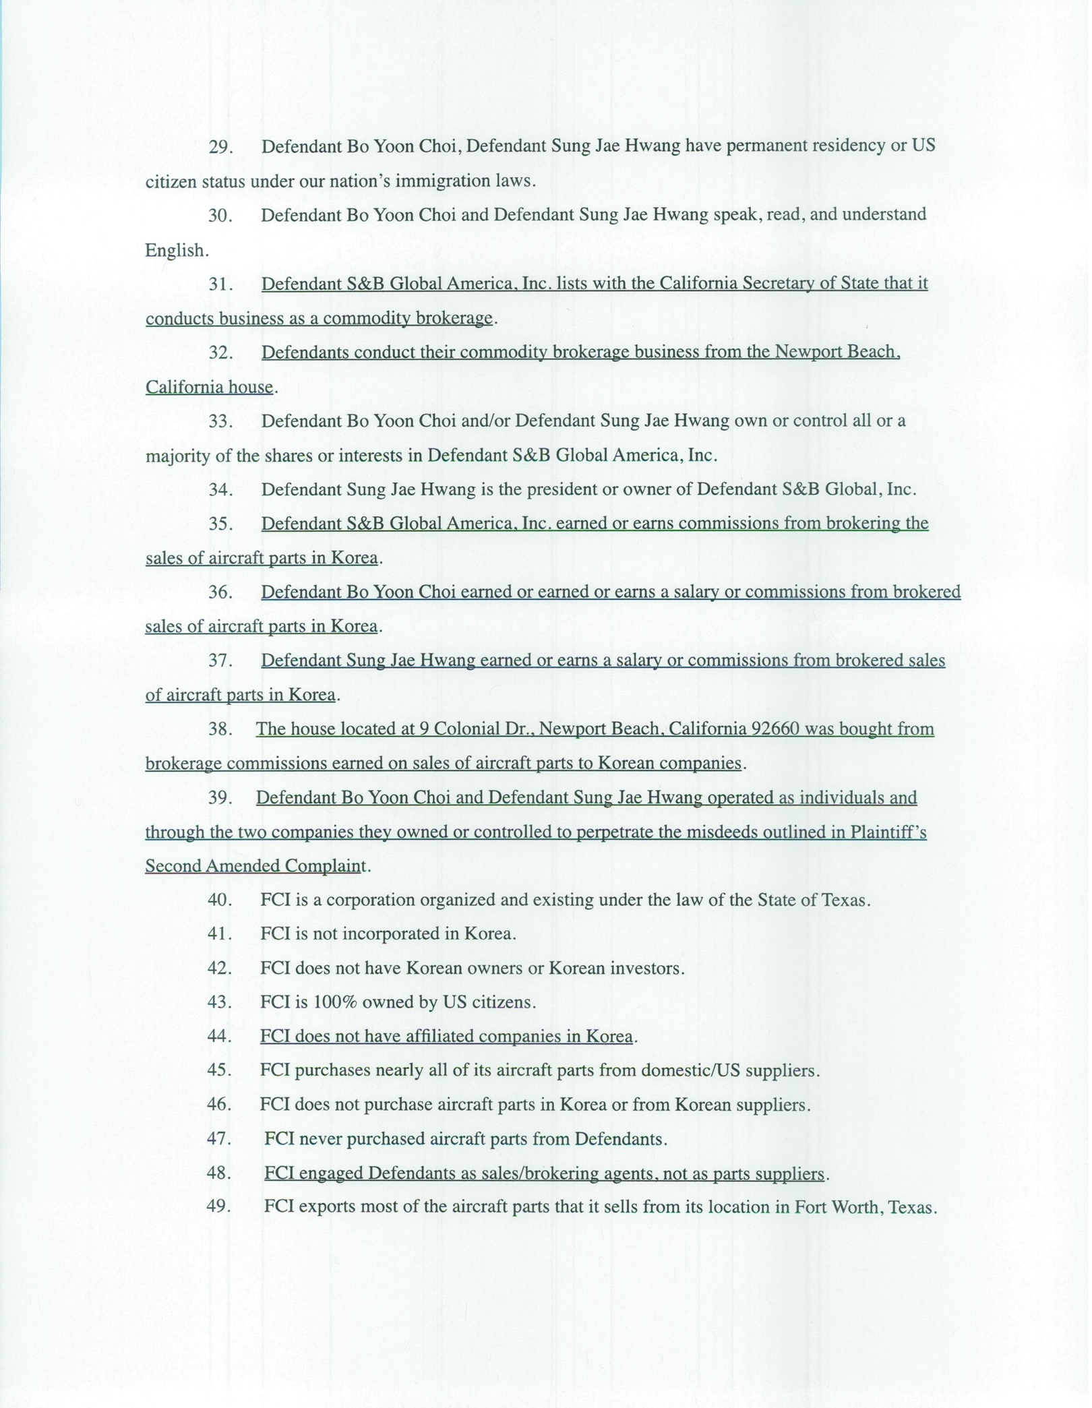
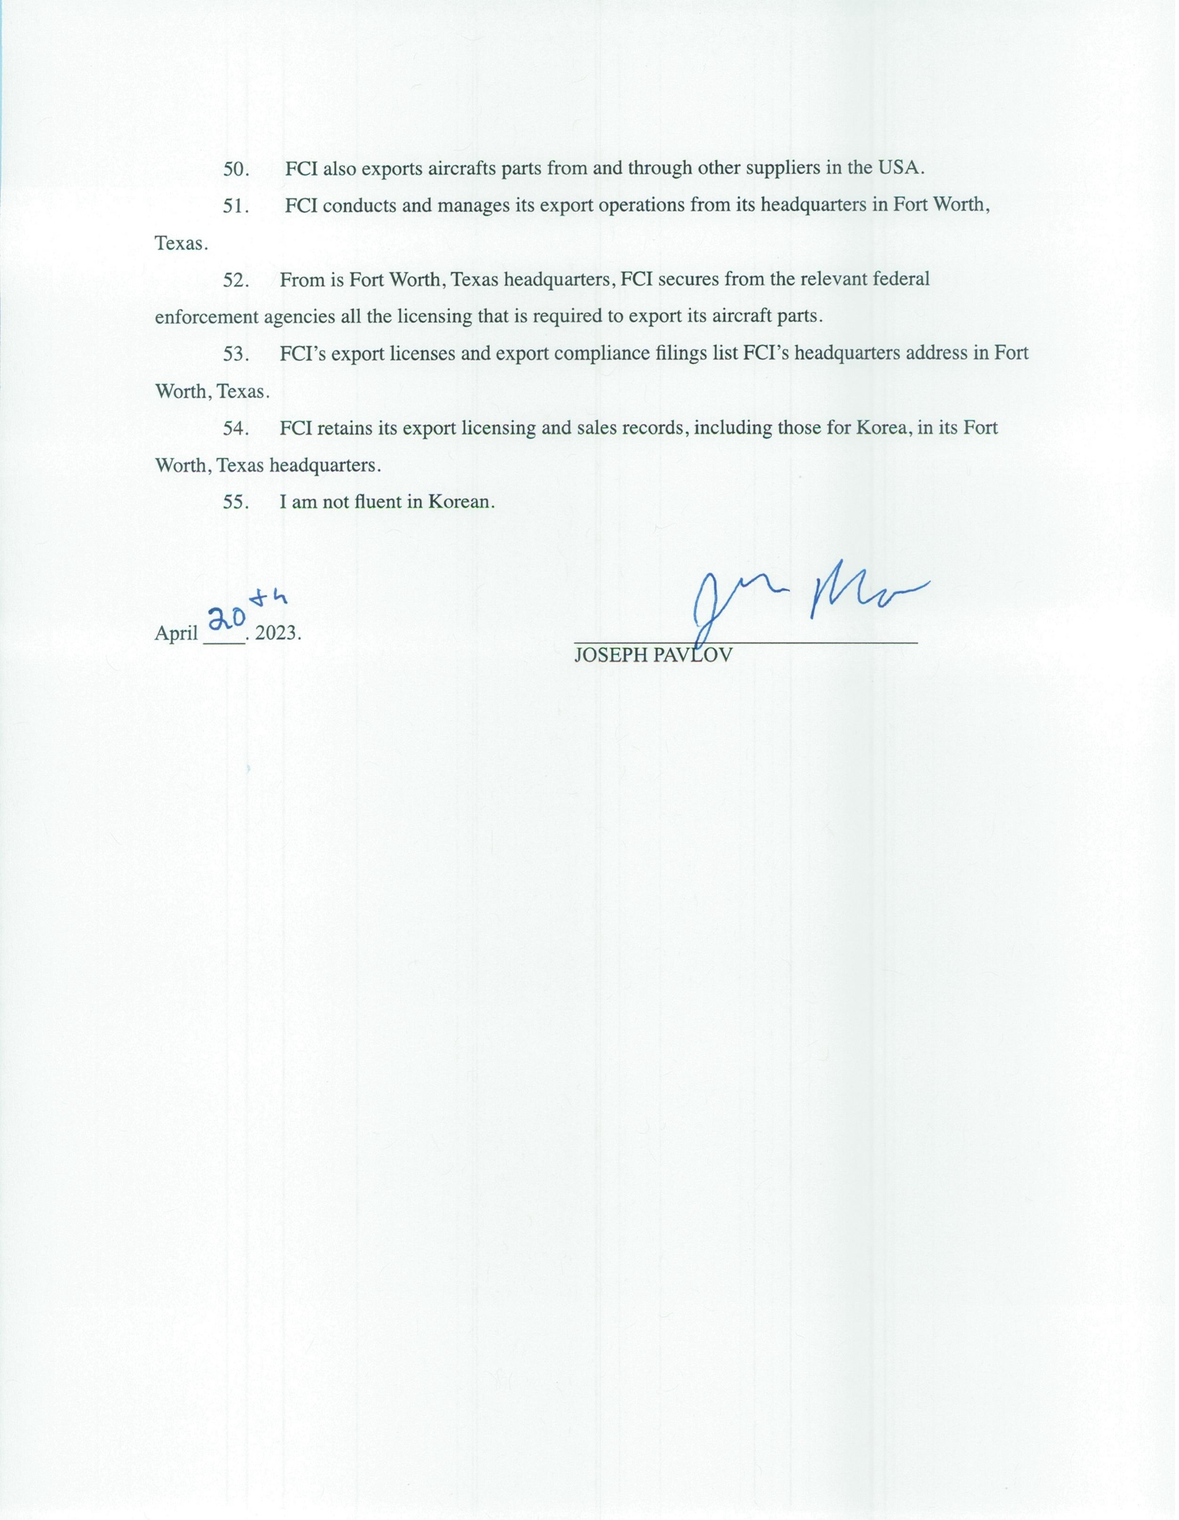
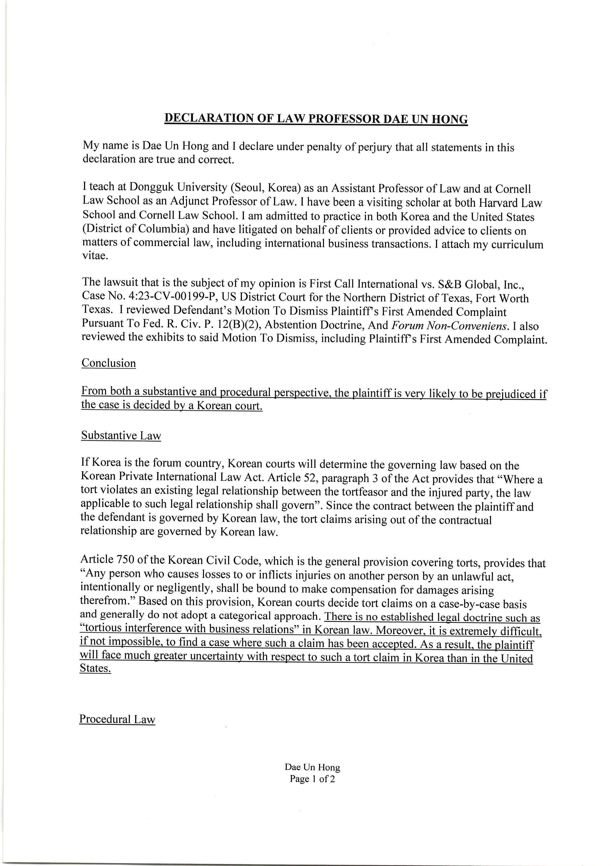
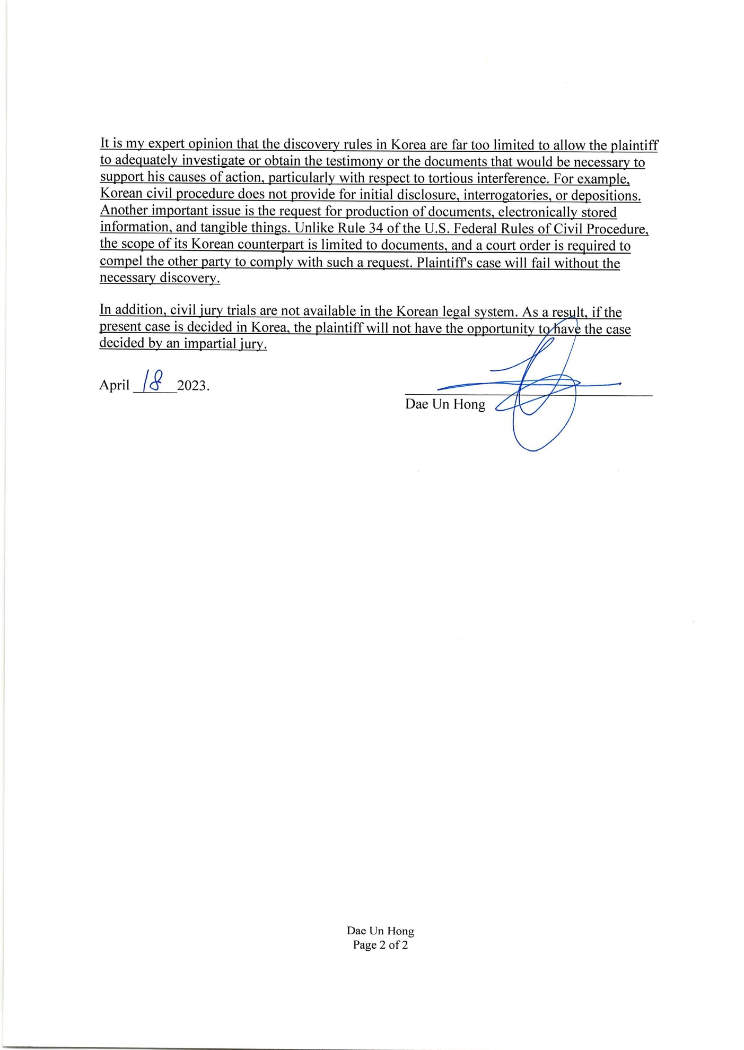
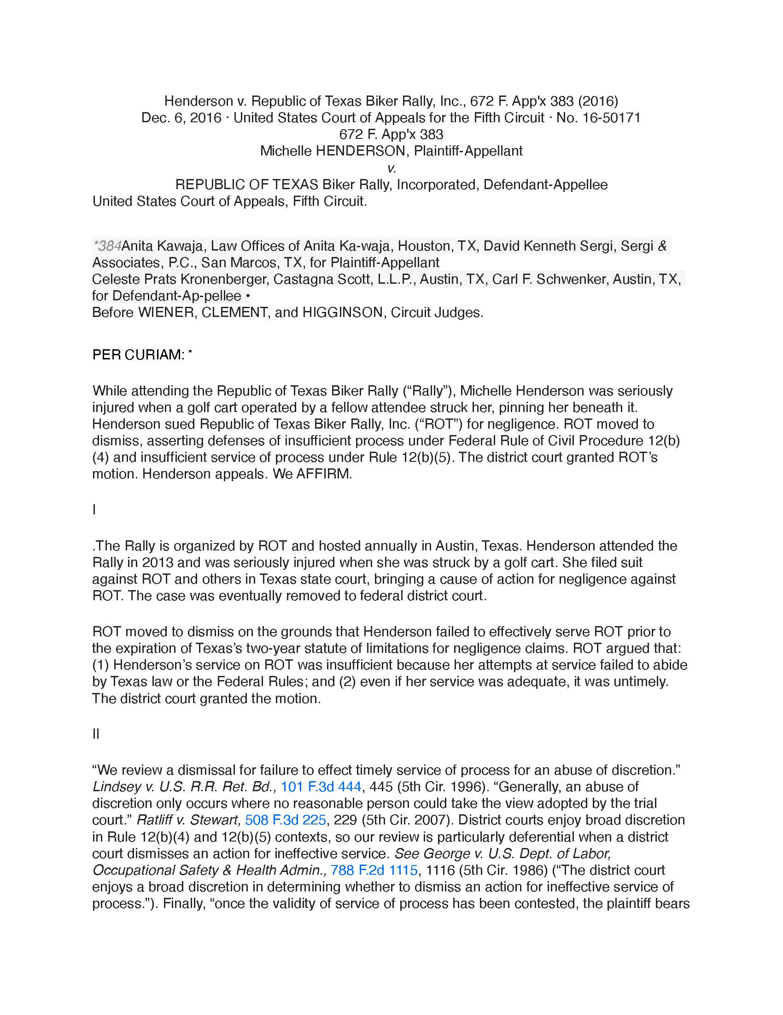
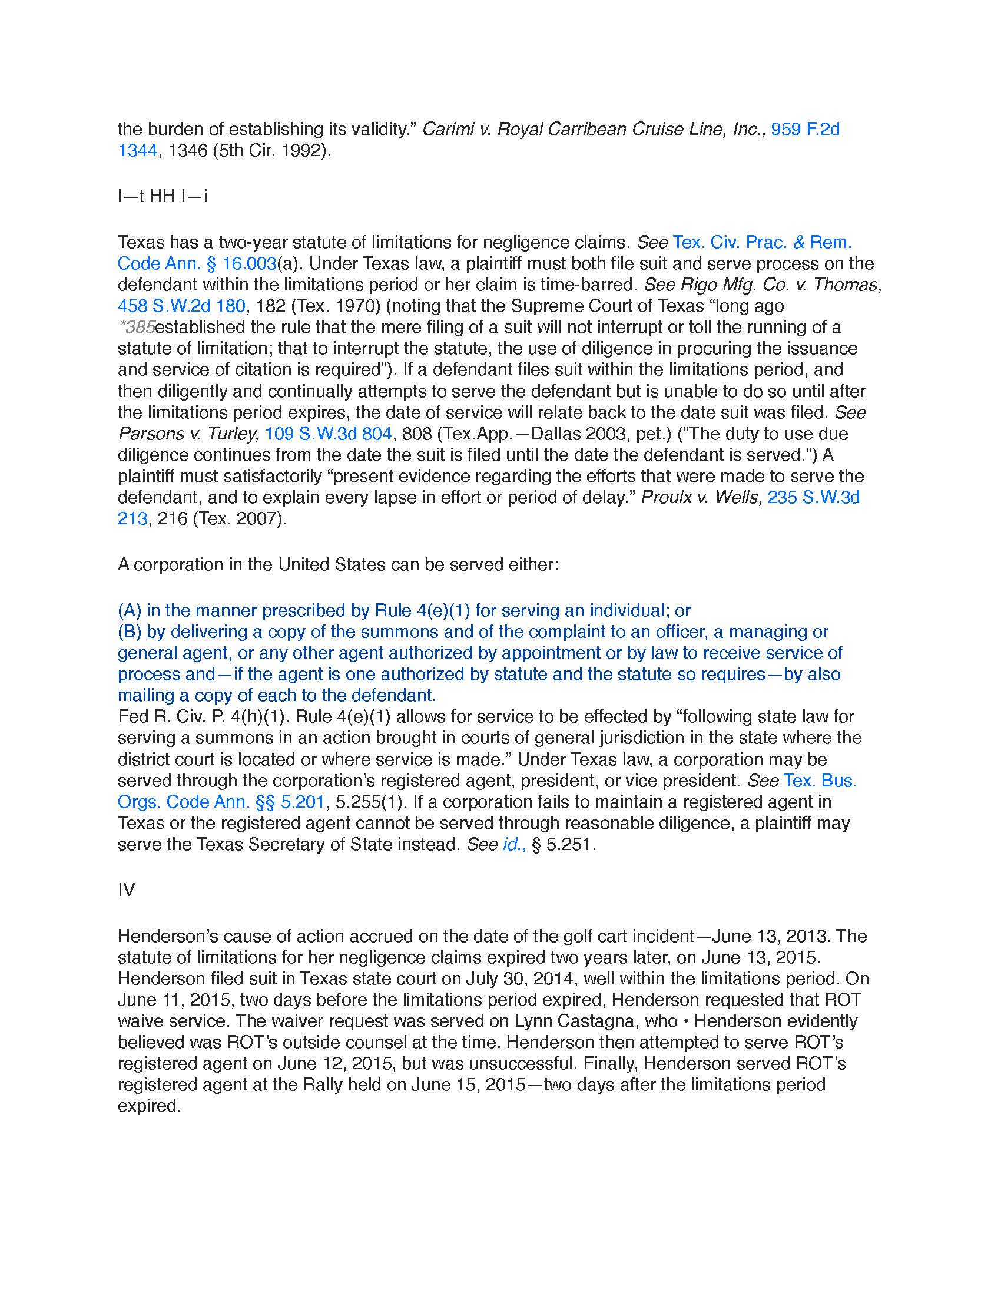
A
